Reading The Bone Sparrow | 07 - Character Voice
Learning intention | - To understand how authors create character voice
I will be successful when: | - I have annotated sentences to describe Subhi's voice  - I have emulated Fraillon's writing to create my own character voice
Engage | Silent starter:  In your exercise books, write:  - What do you think it means "to have a voice"?  - Write a short narrative from the perspective of a young refugee in detention like Subhi. Write what if feels like when nobody will listen to you.
Develop and Discover | Before we start, we need to revisit some important ideas:  Write today's date and learning intention in your exercise book.  Write out the following definitions:  (You don't need to copy down all the affix examples)  Noun - a person, place, thing or idea  Adjective - a word that describes a noun  Verb - a process such an action, thought, feeling or state  Affix - a group of letters that can be added to the beginning or end of a word:  Prefix - an affix that gets added to the beginning of a word to change its meaning.  - bicycle, biplane (two wheels, two wings);  - disorganised, disagree (not organised, not agreeing)  Suffix - an affix that gets added to the end of a word to change its tense, number or word type.  - cycling, cycled (changes tense);  - wearable, attractive (changes verbs to adjectives);  - kindness, purity (changes adjectives to nouns);  - reception, investment (changes verbs to nouns);  Also, remember from last week that an annotation is a written comment that is added to a text.
Apply | In your copy of The Bone Sparrow, find the following on page 7:  “What am I listening to?” she says, the bored all over her face…”  - Notice that the word "bored" doesn't seem to be correct.  - Bored is an adjective - you would describe someone as bored. The author has used it as a noun instead of the expected word "boredom".  - Why do you think the author would use the wrong type of word on purpose?  Zana Fraillon uses adjectives in the place of nouns by removing the suffix. This makes the description more vivid, and reminds the reader that Subhi is young, and that English is not his first language.  Annotate  You will need to use different colours to annotate the sentence:  - Describe what's unusual about the word.  - Explain what it makes you think or feel.  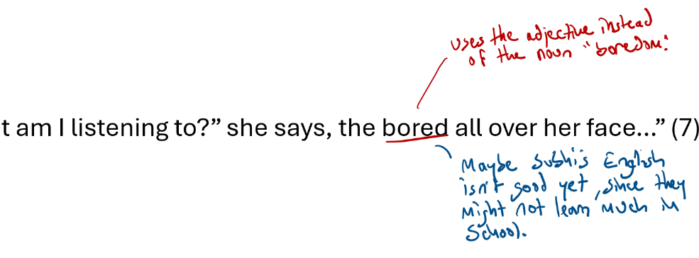  Now you try.  Find the following lines in your novel and repeat the same annotation process:  - “I not hungry much, Subhi love.” (page 3)  - “What’s with the duck?” Queeny says, picking it up and looking at it with that hard on her face…” (page 15)  The author also uses verbs in the place of adjectives for the same reasons.  Add the following to your annotations:  - “Harvey tells them to get inside. Tells them about the sun being burning today…” (page 16)
Explore and extend | Time to experiment:  How might Subhi say the following sentences? Share how you might write them using the same techniques.  (e.g. you might change thirsty to thirsting  - Eli looked really thirsty, and I could tell he was mad.  - The last time the jackets sent a young boy to Alpha, they came back different.  Writing task (10 minutes)  - Look at the short narrative you wrote at the very beginning of the lesson (the silent entry task).  - Re-write it, using today's technique to show the character's voice.  If you weren’t able to write your own narrative at the beginning of the lesson, then try to rewrite this example:  This morning I woke up to the sound of shouting. Half in English and half in another language I couldn’t recognise.  When I rubbed my eyes and stuck my head out of the tent, one of the men was already walking away. The other man – the one that was still there – looked at me like it was me that he wanted to hurt. But then his face softened a bit, even though he was still red and shaking as if he might pop.  He stepped over to the tent. “It’s nothing you need to worry about, boy.” He squeezed my shoulder and tried to smile.  I felt something inside that didn’t feel good, like I was hungry but in my chest.
Review and reflect:
You will need

